UNITED STATES

SECURITIES AND EXCHANGE COMMISSION

Washington, D.C. 20549

FORM 8-K

CURRENT REPORT

Pursuant to Section 13 or 15(d) of the Securities Exchange Act of 1934

Date of Report (Date of earliest event Reported): May 7, 2026

Scholar Rock Holding Corporation

(Exact Name of Registrant as Specified in Charter)

Delaware

(State or Other Jurisdiction of

​​​

001-38501

(Commission File Number)

​​​

82-3750435

(I.R.S. Employer Identification Number)

Incorporation)

301 Binney Street, 3rd Floor, Cambridge, MA 02142

(Address of Principal Executive Offices) (Zip Code)

(857) 259-3860

(Registrant’s telephone number, including area code)

(Former name or former address, if changed since last report)

Check the appropriate box below if the Form 8-K filing is intended to simultaneously satisfy the filing obligation of the registrant under any of the following provisions:

- Written communications pursuant to Rule 425 under the Securities Act (17 CFR 230.425)

- Soliciting material pursuant to Rule 14a-12 under the Exchange Act (17 CFR 240.14a-12)

- Pre-commencement communications pursuant to Rule 14d-2(b) under the Exchange Act (17 CFR 240.14d-2(b))

- Pre-commencement communications pursuant to Rule 13e-4(c) under the Exchange Act (17 CFR 240.13e-4(c)) Securities registered pursuant to Section 12(b) of the Act:
Title of each class | Trading Symbol(s) | Name of each exchange on which registered
Common Stock, par value $0.001 per share | SRRK | The Nasdaq Global Select Market

Indicate by check mark whether the registrant is an emerging growth company as defined in Rule 405 of the Securities Act of 1933 (17 CFR §230.405) or Rule 12b-2 of the Securities Exchange Act of 1934 (17 CFR §240.12b-2). Emerging growth company ☐

If an emerging growth company, indicate by check mark if the registrant has elected not to use the extended transition period for complying with any new or revised financial accounting standards provided pursuant to Section 13(a) of the Exchange Act. ☐

Item 2.02. Results of Operations and Financial Condition.

On May 7, 2026, Scholar Rock Holding Corporation (the “Company”) issued a press release announcing its financial and operating results for the quarter ended March 31, 2026.

A copy of the press release is being furnished as Exhibit 99.1 to this Report on Form 8-K.

The information in this Report on Form 8-K and Exhibit 99.1 attached hereto is intended to be furnished and shall not be deemed “filed” for purposes of Section 18 of the Securities Exchange Act of 1934, as amended (the “Exchange Act”), or otherwise subject to the liabilities of that section, nor shall it be deemed incorporated by reference in any filing under the Securities Act of 1933, as amended, or the Exchange Act, except as expressly set forth by specific reference in such filing.

Item 7.01. Regulation FD Disclosure.

The Company will utilize slides during its conference call scheduled for 8:00 am ET on May 7, 2026 to announce its financial and operating results for the fiscal quarter ended March 31, 2026 and to provide a business update. A copy of the slides is furnished as Exhibit 99.2 to this Current Report on Form 8-K and is incorporated by reference into this Item 7.01 as if fully set forth herein.

The information in this Current Report on Form 8-K and Exhibits 99.1 and 99.2 attached hereto are intended to be furnished and shall not be deemed “filed” for purposes of Section 18 of the Exchange Act, or otherwise subject to the liabilities of that section, nor shall they be deemed incorporated by reference in any filing under the Securities Act or the Exchange Act, except as expressly set forth by specific reference in such filing.

Item 9.01. Financial Statements and Exhibits.

(d) Exhibits

Exhibit
No. | ​​ Description
99.1 | Press Release issued by the Company on May 7, 2026, furnished hereto.
99.2 | Scholar Rock Holding Corporation Corporate Presentation dated May 7, 2026,
99.2 | furnished hereto.
104 | Cover Page Interactive Data File (embedded within the Inline XBRL document).

SIGNATURE

Pursuant to the requirements of the Securities Exchange Act of 1934, the registrant has duly caused this report to be signed on its behalf by the undersigned hereunto duly authorized.

Scholar Rock Holding Corporation

Date: May 7, 2026 By: /s/ Junlin Ho

Junlin Ho
General Counsel & Corporate Secretary

Exhibit 99.1
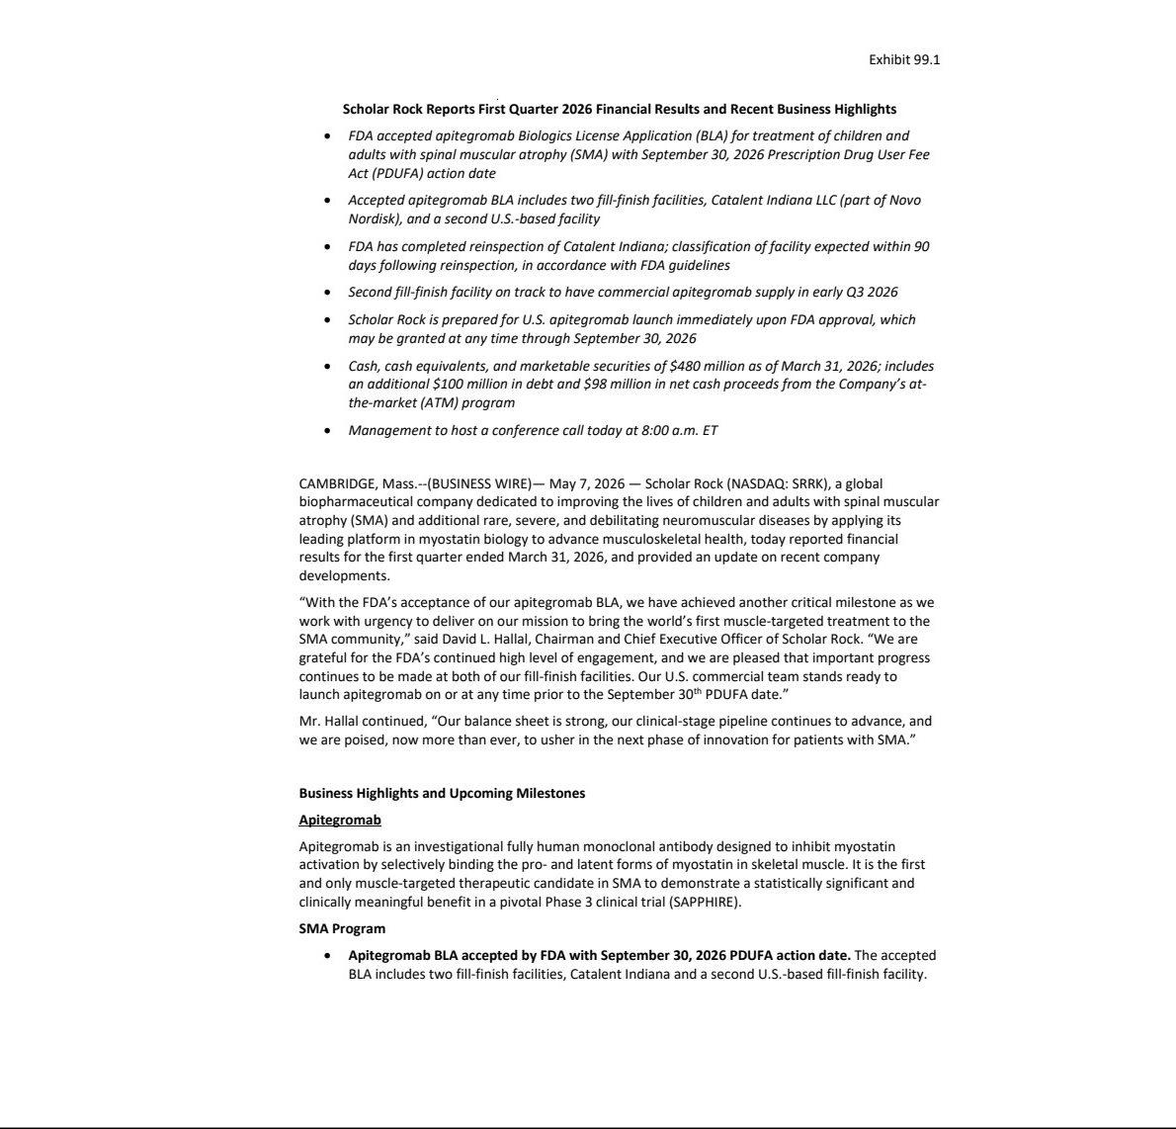

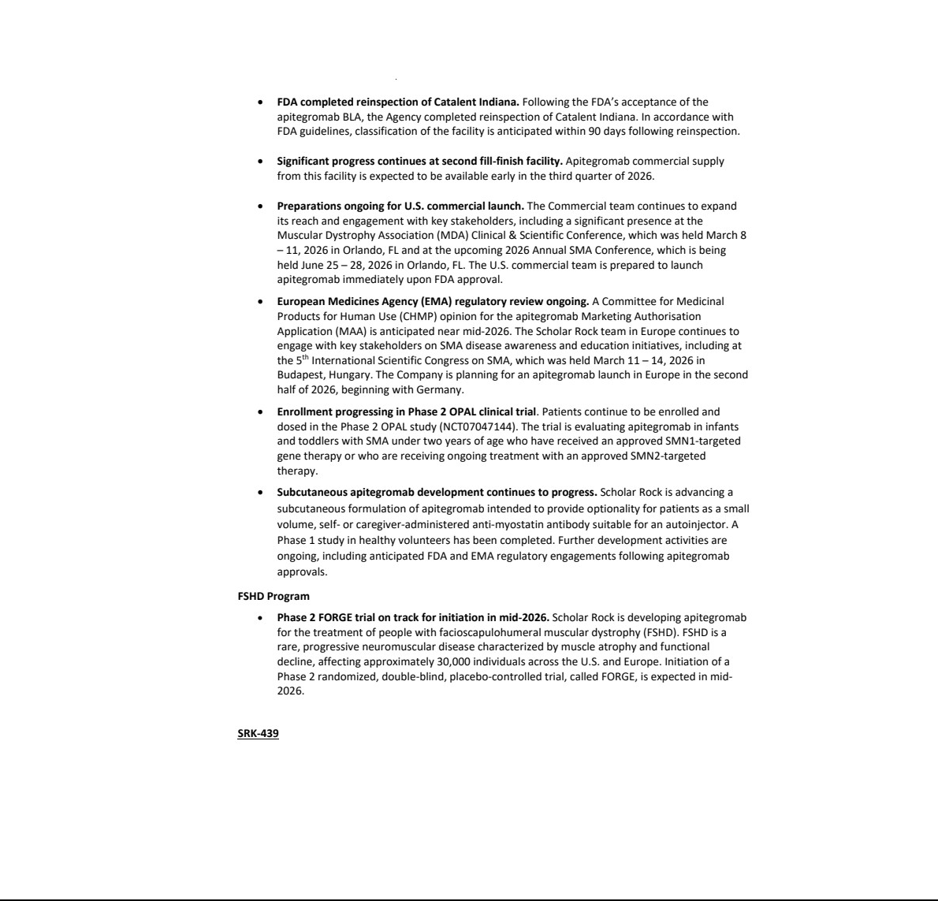

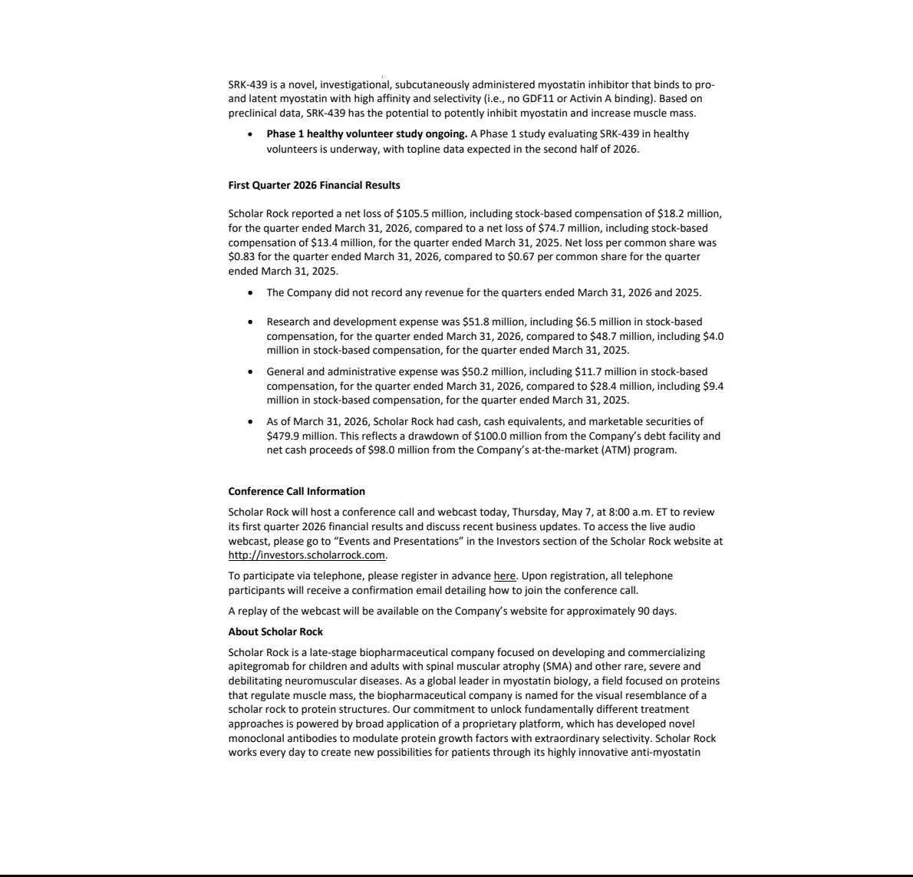

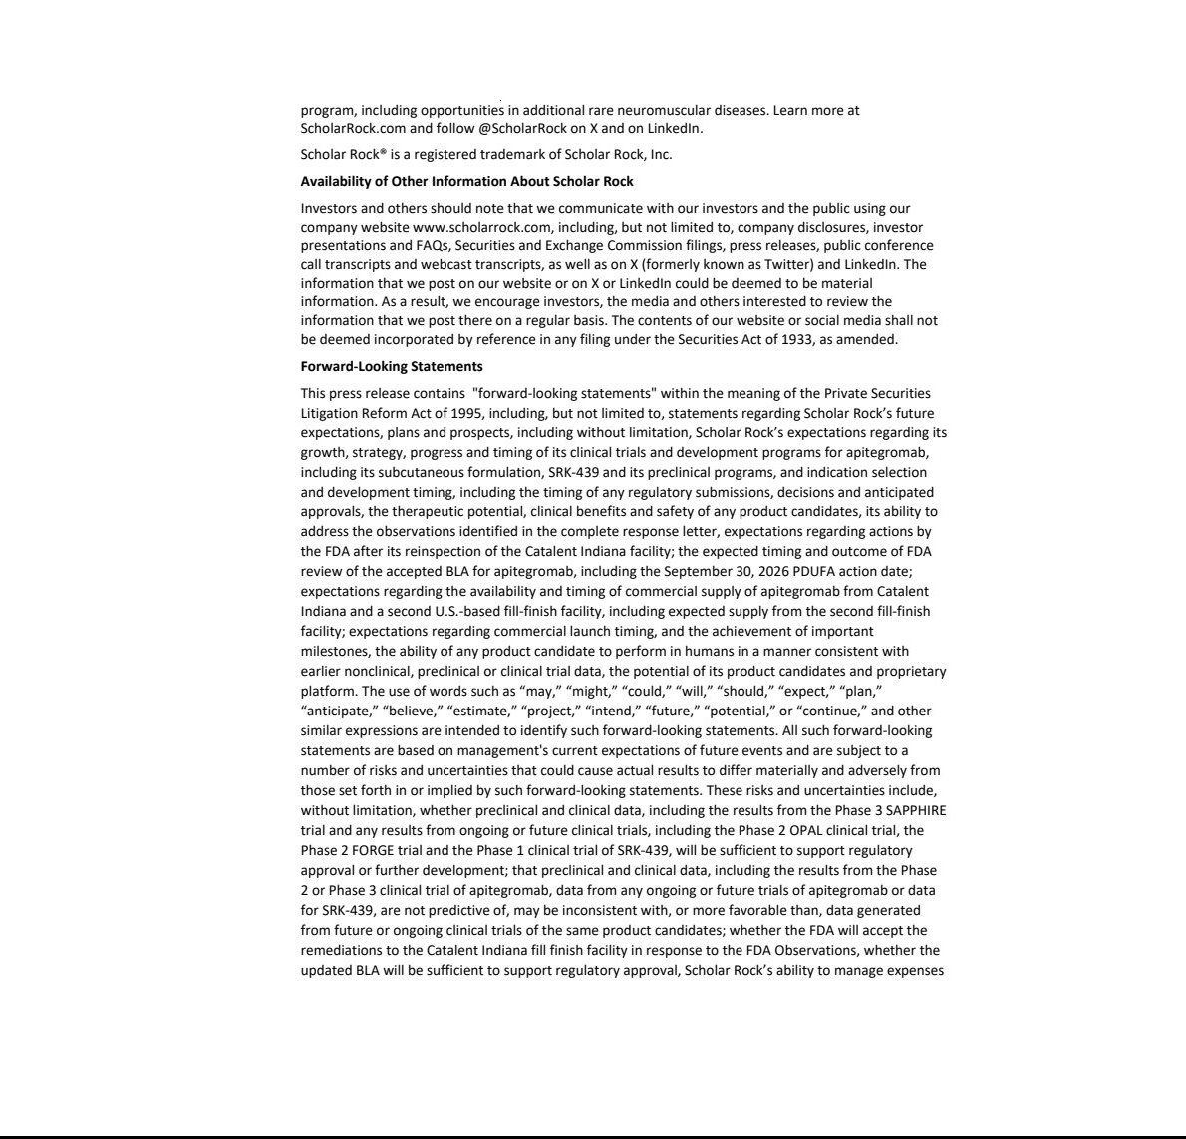

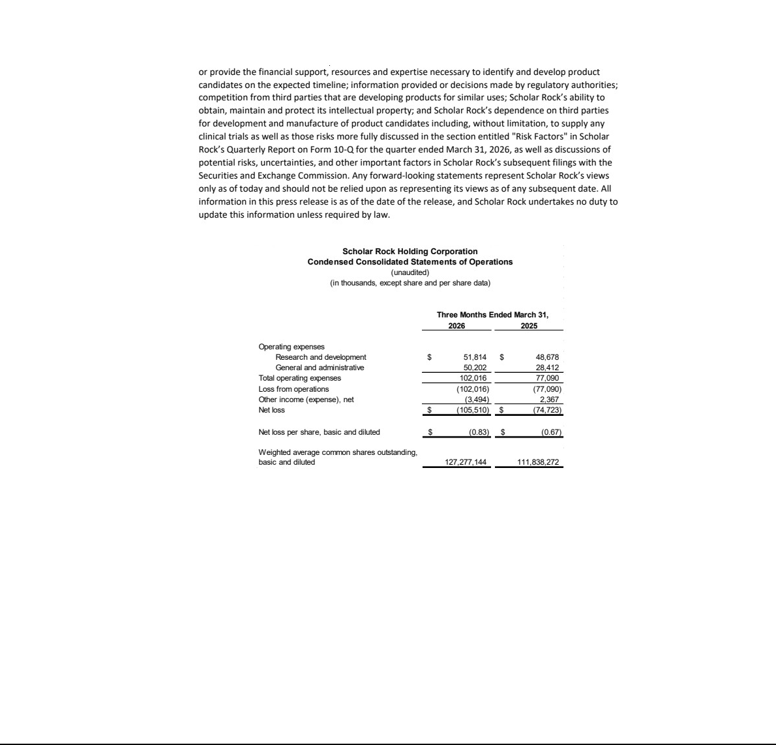

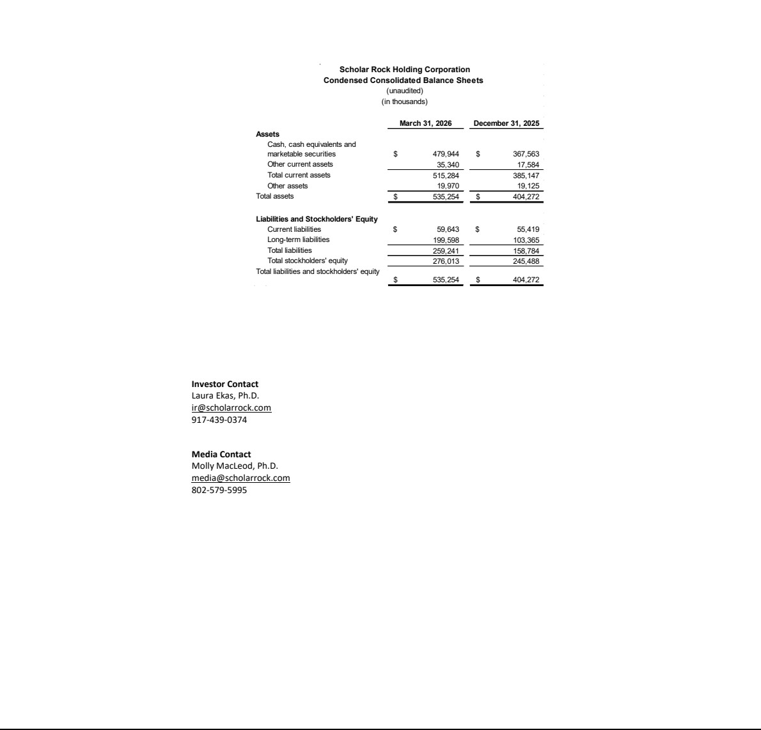

Exhibit 99.2






